# Project Report

41891 - Professional Practice in IT

Create a 3D Video Game

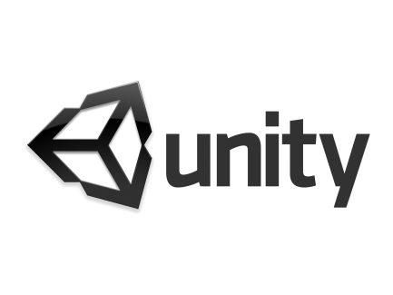

G00314689

Year 3

Software Development

Stephen Gallagher

G00354442

Year 3

Software Development

Dylan Creaven

Table of Content

Project Report 1

Introduction 3

System Requirements 3

Technologies Used 3

Design Methodology 3

Limitations. 3

Research 4

Front end 5

In Game Menu 6

Control Mechanism 6

The Game 7

Chosen type of game 7

Overview of game 7

Goal of game 7

Storyboard of game 7

Game Requirements 7

Possible tests 8

Game Design Process Pitfalls 8

References 9

Recommendations for Future Development 10

Conclusion 10

## Introduction

We set out in this project to challenge ourselves to create something using software that we had never used before. We had some experience using the 2D version of Unity, a development platform, but the 3D version of it was completely different in terms of tools, how to use it, and to put together a whole game when compared to the 2D version. It was going to involve a steep learning curve and teamwork to create a working 3D game. We prepared a schedule of the weeks ahead to meet and gave ourselves targets to hit. We took some setbacks in our schedule, but we were able to deliver what we believe is a good game before the deadline.

## System Requirements

The system requirements for this game are very basic. The game is does not exhaust the computer’s hardware. So, any PC with say a minimum of any i3 processor, 2GB Ram, a few 100MB(?) of space, Windows 7/8/10. It is a basic demo game, with a single level and will run on virtually every PC.

## Technologies Used

We primarily used Unity 3D development platform for creation and development of the game. We used this because we were already familiar with the UI and layout of Unity from our 2D modules, just not familiar with any of the 3D controls, tools or functions, but we felt that a small familiarity was better to start with than no familiarity with a brand new platform such as CryEngine3, Indie Game Maker, GDevelop or Unreal Engine. Unity gave us the ability to just create the game our way, with freedom of the creative design, even the ability to import our own created 3D characters if we wished while Unity handled the compiling into the different platforms e.g. PC, PS4, iOS, Xbox One, Android. For any created characters, we used Blender, an open-source computer graphics software toolset. Blender gives you everything you need to sculpt and mould your own characters. A good feature of Blender is that Unity supports Blender files, so it was easy to import and use our creations immediately in Unity in our game.

## Design Methodology

The methodology employed by us was a **scrum** methodology. We thought scrum would be optimal for us, in a student environment, where our time is already grouped by weeks/days so using a sprint-orientated methodology was ideal for us. We chose scrum for some adaptability and flexibility in terms of our schedule, which can be hectic as students, and so we would be forced to work closely on the code together as a single unit. Our mentor also contributed to the scrum methodology by not telling what to do/ what not to do which feeds into the lack of “leader” in a scrum workplace. This also helped boost our morale while in development as we had creative freedom and thus were invested into the game more and identified with the project.

## Limitations.

There wasn’t much limitations in the way of bugs/errors/Unity problems as we understood most of the basic concepts of our design from our 2D module and we used a lot of Unity documentation, YouTube tutorials and advice from seasoned programmers to help us in development of the game, resulting in few programming limitations. There was a lot of *time* limitations though, with not only doing our class work and study during the weeks of development but with the projects we had for our other classes. We got through this by sticking to our schedule and project plan strictly and communicating regularly as we could with our mentor and with each other so that we didn’t fall too far behind in our development.

## Research

***What is a 3D Game?***

3D gaming is interactive computer entertainment that is graphically presented in the three dimensions of height, width and depth; the addition of depth to 2D gaming enabled the exploration of virtual worlds with more realistic representation.

Example image of a 3D game below:

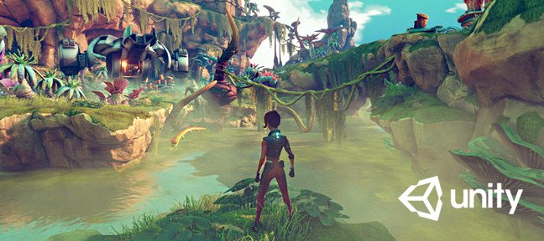

What are examples of 3D games?

**3D games:**

**1) Call of duty modern warfare**

**2)Battlefield v**

**3)Fortnite**

Pictures of the games in list above as an insight to a **3D** game:

1) 2) 3)

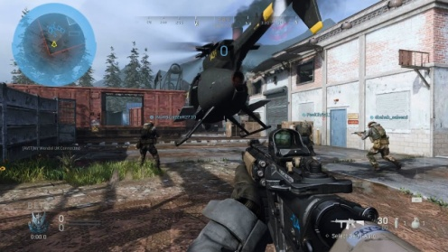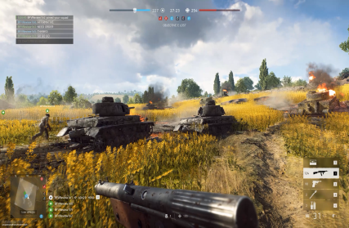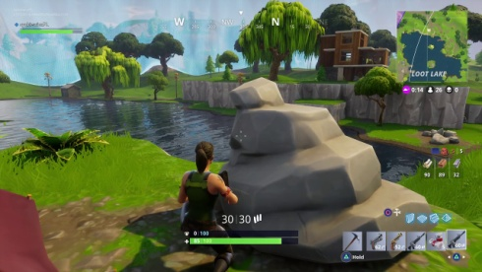

## In Game

We chose the objective of the game to be very basic, the purpose of the player is simply to reach a flag at the end of the map and to not get killed by any of the enemies along the way. Once they reach the flag they have to bring the flag back to the castle and not die.

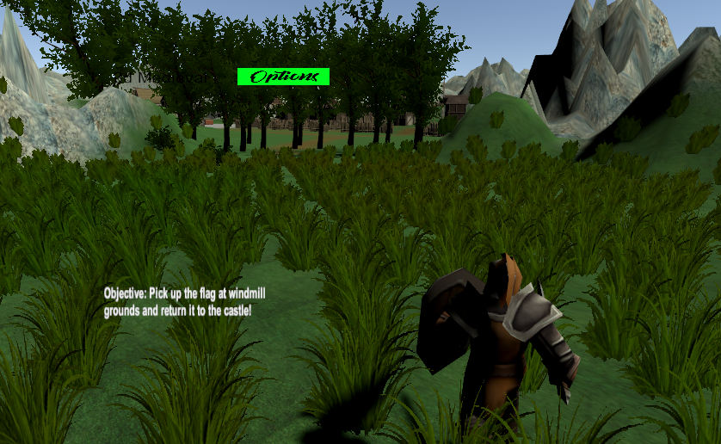

There is an Options Button on the screen for the Player to bring up a pause menu and change volume or quit to main menu

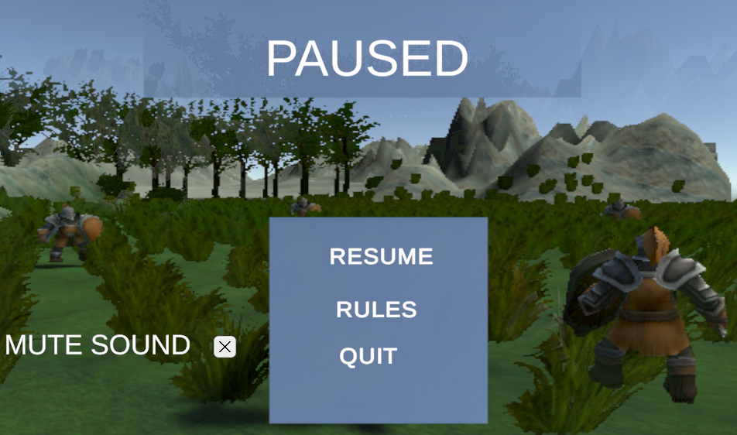

In the Main Menu, there is a Start button, to begin the day, and a Rules button to show the player’s what to do and how to play the game.

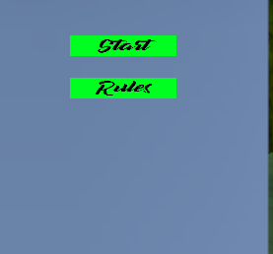

Below is the Rules scene/menu which gives a brief description on how to play/ understand the game and its objectives.

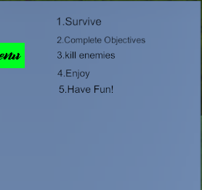

We took inspiration from classic shooters such as Nightfire, GoldenEye, Halo 3 for its Capture the Flag scenario. We also took inspiration from ‘From Honor’ and the Elder Scrolls IV: Skyrim as the basis for our Vikings/ Scandinavian/Medieval atmosphere and environment.

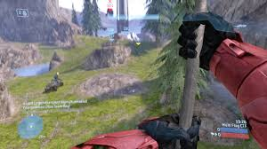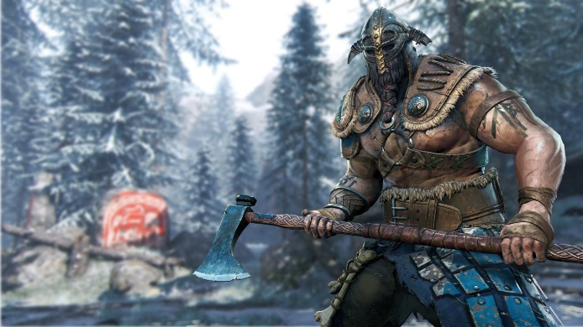

Figure 1 For Honor - Viking character

Figure 2 Halo 3 - Capture the Flag

## Control Mechanism

For my game I will have my game controlled using the **arrows** to look **(left and right)** if wantedor **WASD** keys to move (in all directions) while having the **spacebar** to Attack.

As displayed below in the image and if researched, using either of these two types of control mechanisms can be quite effective and nice to use in games.

Images below:

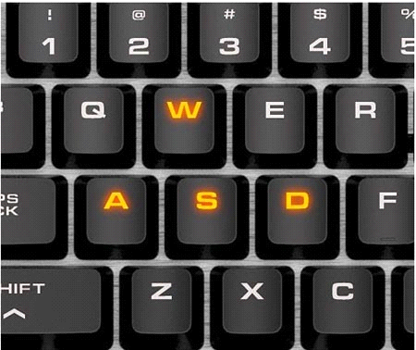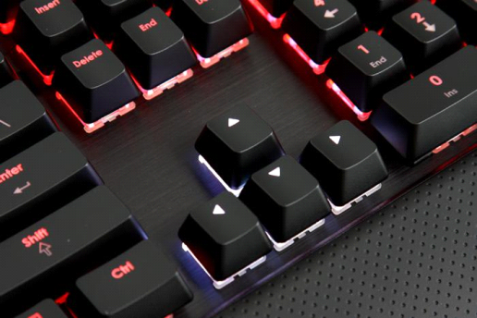

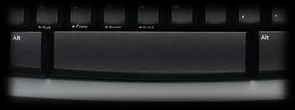

## The Game

### Chosen type of game

The type of game we Have chosen is a melee medieval 3D game. We Have Chosen to go with this type of game as it would be the type of game we would preferably go for if choosing a game to play. We feel that there are many shooting games out now and are very common but hopefully we can make a game that is unique and that changes the experience for the user like no other game.

### Overview of game

The game will consist of a medieval character that can attack his enemies coming at him using his sword. Attacking to stay alive, trying to keep that health bar to maximum for long as possible while trying to get to the objective, that being make it to the final objective and complete the game.

### Goal of game

To keep going killing the enemies coming at you till you get to the final objective. The final objective being reach the castle.

### Storyboard of game

The story of the game will be a heartfelt survival where the medieval player is trying to stay alive and not be taken down by these enemies that are trying to cause harm to the player. The tense/stress of keeping this player alive for you to reach the final objective will attract an addictive experience for the user making it hopefully a well-liked game for all.

## Game Requirements

Some game requirements listed below:

* Create a main character
* Character being able to Attack
* Character being able to kill enemies if player hits them
* enemy health
* player movement using WASD
* Main menu
* Pause menu
* Game over screen when dead
* Enemies inflicting damage to player

## Possible tests

Possible tests:

* transitioning to and from each scene (menu – > gameplay - > pause menu – > end)
* Player being able to attack
* control mechanism working (WASD or arrows and left click)
* Displaying game over scene when dead (game over)
* Menu buttons work
* Additional features work correctly
* Enemy damage to player

## Game Design Process Pitfalls

Looking into the designing of a game for this project we came across an interesting website which had listed the top 10 game design process pitfalls and hopefully after our research I don’t land in one of these pitfalls or one of my own.

we found reading this that it gave us a broader outlook on the importance of the game design process and things that may be overlooked.

The website listed out the following and discussed them in detail:

1. Not Structuring Time for Game Playing

2. Placing Too Much Importance on Paper Designs

3. Peer Review Not Taken Seriously

4. Decision-Maker Picked for His Producer Skills

5. Not Taking Advantage of Placeholders

6. Allowing the Story to Control the Game Design

7. Not Giving Designers Enough Tools

8. Entering Production Without Something Fun

9. Not Keeping Design Documentation Up to Date

10. Not Making Outside Play tests Part of The Process

Website: <https://www.gamasutra.com/view/feature/132408/10_game_design_process_pitfalls.php>

## References

3D Game tutorial videos saved in personal playlist which found helpful throughout project

<https://www.youtube.com/playlist?list=PLm46bxzBw9LtspneRzpph4EVfLq5H7QN1>

Design Pitfalls

<https://www.gamasutra.com/view/feature/132408/10_game_design_process_pitfalls.php>

## Recommendations for Future Development

If we were to do this project again with the knowledge we now have, we would try to research more about the animations of the characters as animations like the attacks and idle movements, took a while for us to complete. If we had done more research, we are sure we could have found better, more comprehensive documentation and tutorials on how to design our own animations for the characters. We would also try a more detailed schedule/ project plan because, even though we stuck to it very well, we beleive there is room for improvement for our schedule to ensure a high-quality game/product at the end of the development deadline.

## Conclusion

The type of game we have chosen is down to our own personal preferences and we believe it will be a good game to play for all with an addictive aspect making people want to keep playing.

We believe additional features may be added in time or during development. We also believe more features / requirements will lead to additional time needed and hopefully getting the basics up and working will already lead to a good game. Then to focus on additional features to improve what already would be a good game.

We believe looking at the game from now during the design phase we will have fun creating this game and some stressful moments if things don’t work out, but we think with the right amount of time spent at this game it should be achievable. Hopefully we can get the game up to a good standard and be able to add extra features to make the game even better for the user.

We hope finishing this project that it exceeds our expectations and if not, we will have learned a lesson going forward.